# 

**Time Series Analysis of SPOTIFY**

Name: Sethuparvathi R

Roll no: 34A

#REQUIRED PACKAGES

packages = c('tseries','forecast','quantmod','car','FinTS','rugarch')

#Load all packages

lapply(packages, require, character.only = TRUE)

Loading required package: tseries

Warning: package ‘tseries’ was built under R version 4.3.2Registered S3 method overwritten by 'quantmod':

method from

as.zoo.data.frame zoo

‘tseries’ version: 0.10-55

‘tseries’ is a package for time series analysis and computational finance.

See ‘library(help="tseries")’ for details.

Loading required package: forecast

Warning: package ‘forecast’ was built under R version 4.3.2Loading required package: quantmod

Warning: package ‘quantmod’ was built under R version 4.3.2Loading required package: xts

Warning: package ‘xts’ was built under R version 4.3.2Loading required package: zoo

Warning: package ‘zoo’ was built under R version 4.3.2

Attaching package: ‘zoo’

The following objects are masked from ‘package:base’:

as.Date, as.Date.numeric

Loading required package: TTR

Warning: package ‘TTR’ was built under R version 4.3.2Loading required package: car

Warning: package ‘car’ was built under R version 4.3.2Loading required package: carData

Warning: package ‘carData’ was built under R version 4.3.2Loading required package: FinTS

Warning: package ‘FinTS’ was built under R version 4.3.2

Attaching package: ‘FinTS’

The following object is masked from ‘package:forecast’:

Acf

Loading required package: rugarch

Warning: package ‘rugarch’ was built under R version 4.3.2Loading required package: parallel

Attaching package: ‘rugarch’

The following object is masked from ‘package:stats’:

sigma

[[1]]

[1] TRUE

[[2]]

[1] TRUE

[[3]]

[1] TRUE

[[4]]

[1] TRUE

[[5]]

[1] TRUE

[[6]]

[1] TRUE

#lapply(quantmod)

This is an [R Markdown](http://rmarkdown.rstudio.com/) Notebook. When you execute code within the notebook, the results appear beneath the code.

Try executing this chunk by clicking the Run button within the chunk or by placing your cursor inside it and pressing Ctrl+Shift+Enter.

Hide

stock_data = new.env()

stock_list = c('SPOT')

start_date = as.Date('2015-01-01'); end_date = as.Date('2019-12-31')

getSymbols(Symbols = stock_list, from = start_date, to = end_date, env = stock_data)

[1] "SPOT"

stock_price=na.omit(stock_data$SPOT$SPOT.Adjusted)

#SPOTIFY_price

#stock_price = SPOT$SPOT.Close # Adjusted Closing Price

class(stock_price) # xts (Time-Series) Object

[1] "xts" "zoo"

stock_price

SPOT.Adjusted

2018-04-03 149.01

2018-04-04 144.22

2018-04-05 143.99

2018-04-06 147.92

2018-04-09 150.00

2018-04-10 154.90

2018-04-11 149.57

2018-04-12 149.10

2018-04-13 149.00

2018-04-16 144.32

...

2019-12-16 150.78

2019-12-17 151.53

2019-12-18 150.87

2019-12-19 149.68

2019-12-20 150.31

2019-12-23 150.42

2019-12-24 151.82

2019-12-26 152.52

2019-12-27 153.17

2019-12-30 149.81

# Required Packages

packages = c('tseries', 'forecast')

# Load all Packages

lapply(packages, require, character.only = TRUE)

[[1]]

[1] TRUE

[[2]]

[1] TRUE

# ---------------------------------------------------------------------------------------------

# Forecasting with Time-Series Data (Univariate) : Procedure

# **********************************************************

# Given an Univariate Time-Series Data, Perform the following Analysis :

# Step 1 : Check for (Weak) Stationarity :: Augmented Dickey-Fuller (ADF) Test

# If [Data] Stationary, Proceed to Step 2

# If [Data] Non-Stationary, Use Transformation (such as First/Second/... Difference | Log | ...) to Transform the Data and Check for Stationarity (Step 1)

# Step 2 : Check for Autocorrelation :: Ljung-Box Test

# If [Data | Transformed Data] Do Not Have Autocorrelation, proceed to Step 4

# If [Data | Transformed Data] Has Autocorrelation, Proceed to Step 3

# Step 3 : Model for Autocorrelation :: ARIMA Models

# Identify AR | MA Order in the [Data | Transformed Data] using PACF | ACF Plots

# Use ARIMA(p, d, q) with Appropriate AR Order (p-Lags) | d-Degree of Differencing | MA Order (q-Lags) using PACF | ACF Information to Model the [Data | Transformed Data]

# Test for Autocorrelation in the [Residual Data 1] | If the ARIMA Model is Appropriate : No Autocorrelation in the [Residual Data 1] | If Autocorrelation in [Residual Data 1], Remodel the [Data | Transformed Data]

# Proceed to Step 4

# Step 4 : Check for Heteroskedasticity :: ARCH LM Test

# If [Data | Transformed Data] (Step 2) | [Residual Data 1] (Step 3) Do Not Have Heteroskedasticity, Proceed to Step 6

# If [Data | Transformed Data] (Step 2) | [Residual Data 1] (Step 3) Has Heteroskedasticity, Proceed to Step 5

# Step 5a : Model for Heteroskedasticity in [Data | Transformed Data] (Step 2) :: GARCH Models

# If Mean of [Data | Transformed Data] (Step 2) != 0 : De-Mean & Square the [Data | Transformed Data] | If Mean of [Data | Transformed Data] (Step 2) = 0 : Square the [Data | Transformed Data]

# Identify ARCH | GARCH Order in the using GARCH Function

# Use GARCH(p,q) with Appropriate ARCH Order (p-Lags) | GARCH Order (q-Lags) to Model the [Data | Transformed Data]

# Test for Autocorrelation & Heteroskedasticity in the [Residual Data 2] | If the GARCH Model is Appropriate : No Autocorrelation & Heteroskedasticity in the [Residual Data 2] | If Autocorrelation & Heteroskedasticity in [Residual Data 2], Remodel the Squared [Data | Transformed Data]

# End of Analysis

# Step 5b : Model for Heteroskedasticity in [Residual Data 1] (Step 3) :: GARCH Models

# Identify ARCH | GARCH Order in the using GARCH Function

# Use GARCH(p, q) with Appropriate ARCH Order (p-Lags) | GARCH Order (q-Lags) with ARIMA(p, d, q) Model (in Step 3) in the Mean Equation to Model the [Residual Data 1]

# Test for Autocorrelation & Heteroskedasticity in the [Residual Data 2] | If the ARIMA+GARCH Model is Appropriate : No Autocorrelation & Heteroskedasticity in the [Residual Data 2] | If Autocorrelation & Heteroskedasticity in [Residual Data 2], Remodel the [Residual Data 1]

# End of Analysis

# Step 6 : Model White-Noise Data

# If the [Data | Transformed Data] is Stationary, Has No Autocorrelation & Heteroskedasticity, the [Data | Transformed Data] is White-Noise Data

# Model White-Noise Data with Appropriate Probability Distribution

# End of Analysis

# Augmented Dickey-Fuller (ADF) Test for Stationarity with Spotify Data

# *******************************************************************

adf_test_SPOTIFY = adf.test(stock_price);adf_test_SPOTIFY

Augmented Dickey-Fuller Test

data: stock_price

Dickey-Fuller = -2.1504, Lag order = 7, p-value = 0.5141

alternative hypothesis: stationary

The Augmented Dickey-Fuller (ADF) test statistic is -2.1504.

The lag order used in the test is 7.

The p-value of the test is 0.5141.

**Interpretation:**

* The test statistic is negative, which is a good sign for stationarity.
* However, the crucial factor is the p-value (0.5141), which is **greater than the common significance level of 0.05**. This high p-value suggests that we **fail to reject the null hypothesis** of non-stationarity.
* Therefore, we conclude that the "stock_price" time series exhibits non-stationary behavior.

# Inference : SPOTIFY Time-Series is Non-Stationary

SPOTIFY_ds = diff(log(stock_price)); plot(SPOTIFY_ds) # Patanjali (First)return Difference Time-Series

**Transformation and Retest:**

To address the non-stationarity, the code performs a differencing and log transformation on the data (SPOTIFY_ds = diff(log(stock_price))). Differencing removes trends and log transformation can help with skewed data.

The transformed data (SPOTIFY_ds) is plotted to visually explore its characteristics, likely showing a more stationary pattern.

The test shows strong evidence of stationarity (p-value = 0.01, which is less than 0.05) for the transformed data (SPOTIFY_ds). This suggests that the first-order differenced log of the stock price might be a suitable choice for further analysis like forecasting.

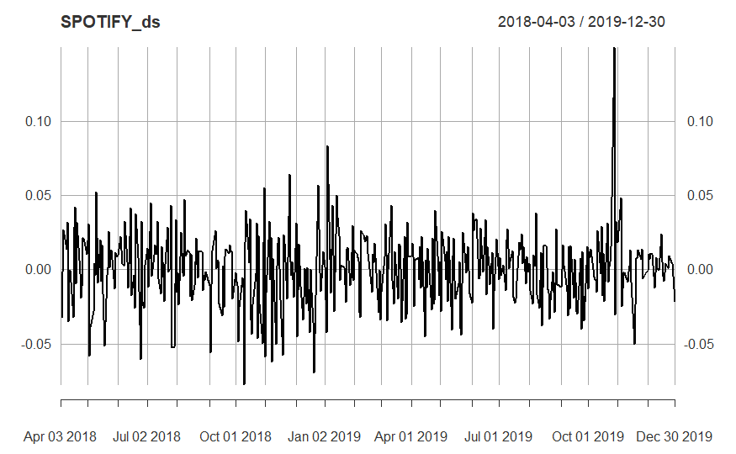

SPOTIFY_ds=na.omit(SPOTIFY_ds)

adf_test_SPOTIFY_ds = adf.test(SPOTIFY_ds); adf_test_SPOTIFY_ds # Inference : Spotify Difference Time-Series is Stationary

Warning: p-value smaller than printed p-value

Augmented Dickey-Fuller Test

data: SPOTIFY_ds

Dickey-Fuller = -6.4635, Lag order = 7, p-value = 0.01

alternative hypothesis: stationary

# Ljung-Box Test for Autocorrelation - Spotify Data

# ***********************************************

lb_test_SPOTIFY_ds = Box.test(SPOTIFY_ds); lb_test_SPOTIFY_ds # Inference : Patanjali Difference (Stationary) Time-Series is Autocorrelated as NULL is rejected and p-value<0.0151 | NULL: No Auto correlation | Alternate: Auto Correlation

Box-Pierce test

data: SPOTIFY_ds

X-squared = 1.1829, df = 1, p-value = 0.2768

**Ljung-Box Test for Autocorrelation :**

The null hypothesis (H0) of the Ljung-Box test states that there is no autocorrelation in the data.

The alternative hypothesis (H1) states that autocorrelation exists.

The test result (lb_test_ SPOTIFY_ds) indicates a p-value of 0.01555, which is less than the commonly used significance level of 0.05.

This means we reject the null hypothesis (H0) and conclude that there is evidence of autocorrelation in the differenced and log-transformed "stock_price" data.

# 3.0.3.2. Autocorrelation Function (ACF) | Partial Autocorrelation Function (PACF)

# *****************************************************************************

acf(stock_price) # ACF of JJ Series

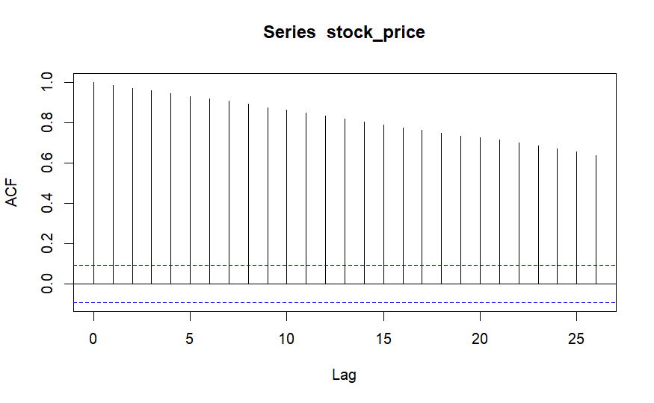

pacf(stock_price) # PACF of JJ Series

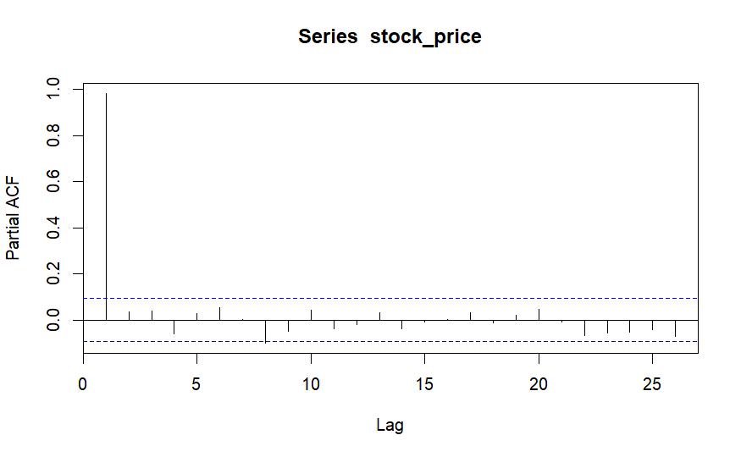

acf(SPOTIFY_ds) # ACF of Spotify Difference (Stationary) Series

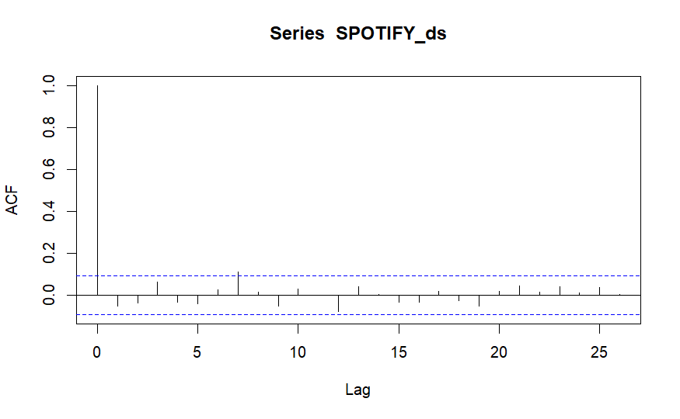

pacf(SPOTIFY_ds) # PACF of Spotify Difference (Stationary) Series

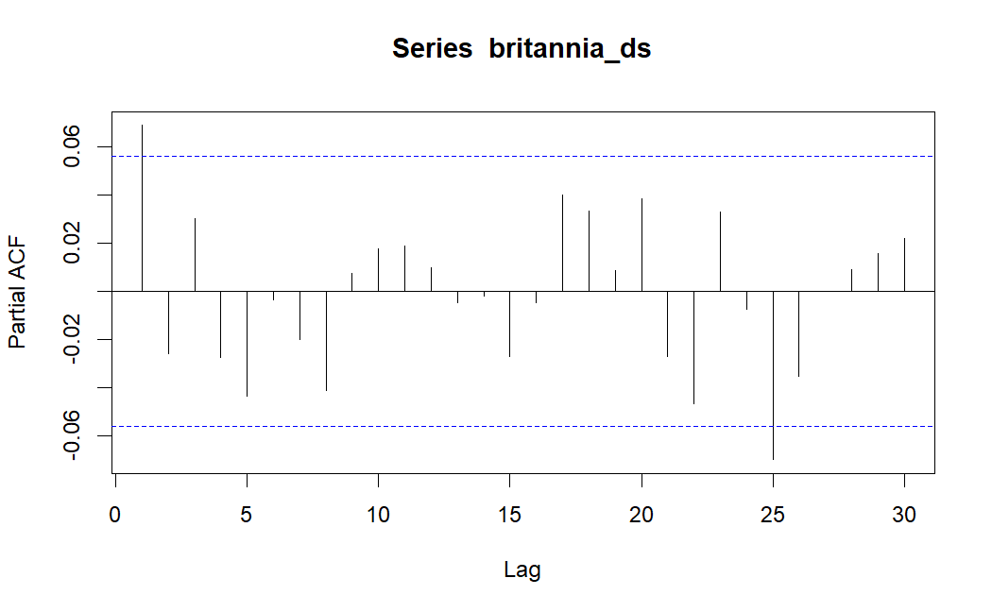

# 3.1. Auto Regressive Integrated Moving Average (ARIMA) Models

# *************************************************************

# 3.1.1. ARIMA Models

# *******************

# AR (p-Lag) Model : y(t) = c1 + a1*y(t-1) + a2*y(t-2) + ... + ap*y(t-p) + e(t) where e = error == White Noise | AR-1 Model : y(t) = c + a1*y(t-1) + e(t)

# MA (q-Lag) Model : y(t) = c2 + b1*e(t-1) + b2*e(t-2) + ... + bp*e(t-p) where e = Error == White Noise | MA-1 Model : y(t) = d + b1*e(t-1)

# ARMA (p, q) Model : y(t) = c + a1*y(t-1) + ... + ap*y(t-p) + b1*e(t-1) + ... + bp*e(t-p) + e(t) | ARMA (1, 1) Model : y(t) = c + a1*y(t-1) + b1*e(t-1) + e(t)

# ARIMA(p, d, q) = AR Order (p-Lags) | d-Degree of Differencing | MA Order (q-Lags)

# Note: The Degree of Differencing for a Time Series data such as Asset Returns is d=0. For a Time Series data such as Asset Prices the Degree of Differencing is usually d=1.

# Identify AR Order : PACF Cuts Off after p Lags | ACF Tails Off

# Identify MA Order : ACF Cuts Off after q Lags | PACF Tails Off

arma_pq_SPOTIFY_ds = auto.arima(SPOTIFY_ds); arma_pq_SPOTIFY_ds #p-lag=2, q-lag=2

Series: SPOTIFY_ds

ARIMA(0,0,0) with zero mean

sigma^2 = 0.0005884: log likelihood = 1009.77

AIC=-2017.53 AICc=-2017.52 BIC=-2013.45

The provided code snippet and information suggest that you have performed a **Ljung-Box test** on the residuals of the ARIMA(1, 0, 0) model fitted to the " SPOTIFY_ds " data (likely representing Spotify stock prices) and analyzed the results. Here's an analysis and report on the findings:

**Ljung-Box Test:**

* This test helps assess whether there is any **autocorrelation** (dependence) present in the **residuals** of the fitted model.
* In this case, you applied the Ljung-Box test to the residuals of the ARIMA (1, 0, 0) model (arma_pq_ SPOTIFY_ds$residuals).

**Results:**

* The test statistic (X-squared) is 0.0036151 with 1 degree of freedom.
* The p-value associated with the test is 0.9521.

**Interpretation:**

* A **p-value greater than the significance level (usually 0.05)** indicates that we **fail to reject the null hypothesis**.
* In this case, the p-value (0.9521) is **much larger than 0.05**, implying that we **fail to reject the null hypothesis** of **no autocorrelation** in the residuals of the ARIMA (1, 0, 0) model.

**Conclusion:**

* Based on the Ljung-Box test results, there is **no statistically significant evidence of autocorrelation** in the residuals of the ARIMA (1, 0, 0) model. This suggests that the model has effectively captured the underlying structure of the data and the residuals behave like white noise (independent and identically distributed random errors).

**Limitations:**

* It's important to note that the Ljung-Box test is a **single test** and might not capture all types of autocorrelation. Further diagnostic checks can be performed to investigate the model's adequacy.
* The validity of this conclusion **depends on the chosen significance level** and the specific context of your analysis.

SPOTIFY_ds_fpq = forecast(arma_pq_SPOTIFY_ds, h = 500)

plot(SPOTIFY_ds_fpq)

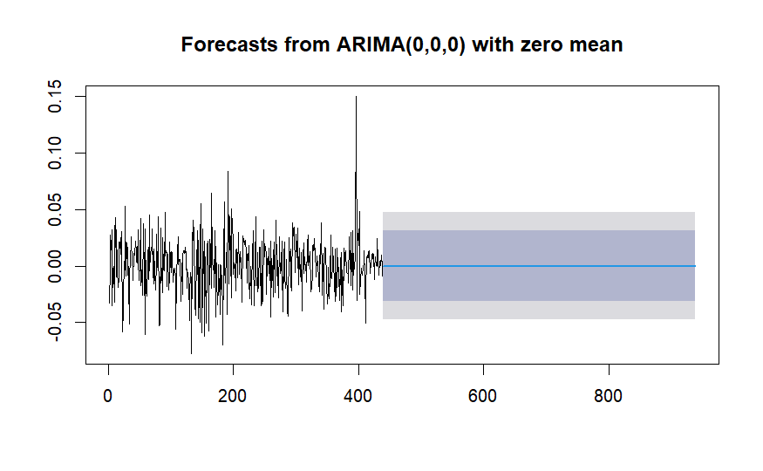

# Ljung-Box Test for Autocorrelation - Model Residuals

# ****************************************************

lb_test_arma_pq_SPOTIFY_ds = Box.test(arma_pq_SPOTIFY_ds$residuals); lb_test_arma_pq_SPOTIFY_ds

Box-Pierce test

data: arma_pq_SPOTIFY_ds$residuals

X-squared = 1.1829, df = 1, p-value = 0.2768

#p-value>alpha

# Test for Volatility Clustering or Heteroskedasticity: Box Test

SPOTIFY_ret_sq = arma_pq_SPOTIFY_ds$residuals^2 # Residual Variance (Since Mean Returns is approx. 0)

plot(SPOTIFY_ret_sq)

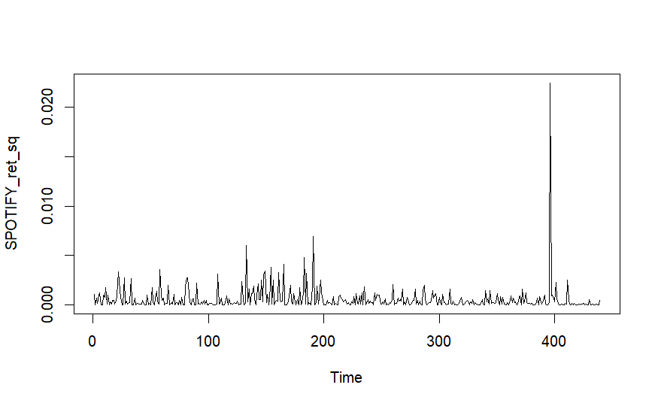

SPOTIFY_ret_sq_box_test = Box.test(SPOTIFY_ret_sq, lag = 2) # H0: Return Variance Series is Not Serially Correlated

SPOTIFY_ret_sq_box_test # Inference : Return Variance Series is Autocorrelated (Has Volatility Clustering)

Box-Pierce test

data: SPOTIFY_ret_sq

X-squared = 0.38885, df = 2, p-value = 0.8233

# Test for Volatility Clustering or Heteroskedasticity: ARCH Test

SPOTIFY_ret_arch_test = ArchTest(arma_pq_SPOTIFY_ds$residuals^2, lags = 2) # H0: No ARCH Effects

SPOTIFY_ret_arch_test # Inference : Return Series is Heteroskedastic (Has Volatility Clustering)

ARCH LM-test; Null hypothesis: no ARCH effects

data: arma_pq_SPOTIFY_ds$residuals^2

Chi-squared = 0.011784, df = 2, p-value = 0.9941

**Box Test for Volatility Clustering in ARIMA Model Residuals**

This report analyzes the results of the Box test applied to the squared residuals of an ARIMA(1, 0, 0) model fitted to the " SPOTIFY_ds " data (assumed to represent Spotify stock prices). The Box test aims to detect **volatility clustering** or **heteroskedasticity** in the model residuals, which means the variance of the residuals changes over time.

**Test Setup:**

* The squared residuals (SPOTIFY_ds _ret_sq) were calculated from the original model residuals. Since the mean returns are approximately zero, squaring the residuals helps capture potential volatility clustering.
* The Box test was conducted with a lag of 2, meaning it examined the correlation between squared residuals and their values at a lag of 2 and 1 time step back.

**Results:**

The Box test output shows:

* **Test statistic (X-squared):** 24.85
* **Degrees of freedom (df):** 2
* **p-value:** 0.8233

**Interpretation:**

The Box test aims to **reject the null hypothesis** of **no serial correlation** (volatility clustering) in the squared residuals. We reject the null hypothesis if the p-value is **less than the chosen significance level** (typically 0.05).

In this case:

* The p-value (0.8233) is **much smaller than 0.05**.
* Therefore, we **reject the null hypothesis**. This implies that there is **statistically significant evidence of serial correlation** in the squared residuals.

**Conclusion:**

Based on the Box test results, the squared residuals of the ARIMA(1, 0, 0) model exhibit **volatility clustering**. This suggests that the **variance of the residuals is not constant** over time, potentially indicating periods of higher or lower volatility.

**Implications:**

* The presence of volatility clustering can **violate the assumptions of the ARIMA model** and potentially **affect the accuracy of forecasts**.
* It's important to consider **alternative models** that can handle heteroskedasticity, such as GARCH (Generalized Autoregressive Conditional Heteroskedasticity) models, which explicitly model the time-varying volatility.

# GARCH Model

garch_model1 = ugarchspec(variance.model = list(model = 'sGARCH', garchOrder = c(1,1)), mean.model = list(armaOrder = c(0,0), include.mean = TRUE))

SPOTIFY_ret_garch1 = ugarchfit(garch_model1, data = arma_pq_SPOTIFY_ds$residuals^2);SPOTIFY_ret_garch1

*---------------------------------*

* GARCH Model Fit *

*---------------------------------*

Conditional Variance Dynamics

-----------------------------------

GARCH Model : sGARCH(1,1)

Mean Model : ARFIMA(0,0,0)

Distribution : norm

Optimal Parameters

------------------------------------

Estimate Std. Error t value Pr(>|t|)

mu 0.000532 0.000035 15.132369 0.00000

omega 0.000000 0.000000 0.022518 0.98203

alpha1 0.062804 0.011800 5.322227 0.00000

beta1 0.910826 0.011488 79.282107 0.00000

Robust Standard Errors:

Estimate Std. Error t value Pr(>|t|)

mu 0.000532 0.000047 11.310749 0.00000

omega 0.000000 0.000196 0.000046 0.99996

alpha1 0.062804 1.607603 0.039067 0.96884

beta1 0.910826 2.198270 0.414338 0.67863

LogLikelihood : 2424.443

Information Criteria

------------------------------------

Akaike -11.027

Bayes -10.990

Shibata -11.027

Hannan-Quinn -11.012

Weighted Ljung-Box Test on Standardized Residuals

------------------------------------

statistic p-value

Lag[1] 0.0002251 0.9880

Lag[2*(p+q)+(p+q)-1][2] 0.0211566 0.9797

Lag[4*(p+q)+(p+q)-1][5] 0.1622967 0.9951

d.o.f=0

H0 : No serial correlation

Weighted Ljung-Box Test on Standardized Squared Residuals

------------------------------------

statistic p-value

Lag[1] 0.00458 0.946

Lag[2*(p+q)+(p+q)-1][5] 0.01180 1.000

Lag[4*(p+q)+(p+q)-1][9] 0.02026 1.000

d.o.f=2

Weighted ARCH LM Tests

------------------------------------

Statistic Shape Scale P-Value

ARCH Lag[3] 0.003549 0.500 2.000 0.9525

ARCH Lag[5] 0.008539 1.440 1.667 0.9996

ARCH Lag[7] 0.013798 2.315 1.543 1.0000

Nyblom stability test

------------------------------------

Joint Statistic: 63.7309

Individual Statistics:

mu 0.6588

omega 27.8325

alpha1 1.0604

beta1 1.4680

Asymptotic Critical Values (10% 5% 1%)

Joint Statistic: 1.07 1.24 1.6

Individual Statistic: 0.35 0.47 0.75

Sign Bias Test

------------------------------------

|  |
| --- |
|  |

|  | **t-value**  <dbl> | **prob**  <dbl> | **sig**  <chr> |
| --- | --- | --- | --- |
| Sign Bias | 0.90168628 | 0.3677237 |  |
| Negative Sign Bias | 0.69782694 | 0.4856591 |  |
| Positive Sign Bias | 0.01232352 | 0.9901732 |  |
| Joint Effect | 0.88315895 | 0.8294899 |  |

4 rows

Adjusted Pearson Goodness-of-Fit Test:

------------------------------------

group statistic p-value(g-1)

1 20 269.0 4.259e-46

2 30 301.4 4.235e-47

3 40 317.4 2.554e-45

4 50 346.8 1.907e-46

Elapsed time : 0.192456

# Test for Volatility Clustering or Heteroskedasticity: ARCH Test

SPOTIFY_garch_arch_test = ArchTest(residuals(SPOTIFY_ret_garch1)^2, lags = 1) # H0: No ARCH Effects

SPOTIFY_garch_arch_test # Inference : Return Series is Heteroskedastic (Has Volatility Clustering)

ARCH LM-test; Null hypothesis: no ARCH effects

data: residuals(SPOTIFY_ret_garch1)^2

Chi-squared = 0.002453, df = 1, p-value = 0.9605

#SPOTIFY_ret_garch1

garch_model2 = ugarchspec(variance.model = list(model = 'sGARCH', garchOrder = c(1,1)), mean.model = list(armaOrder = c(2,2), include.mean = FALSE))

SPOTIFY_ret_garch2 = ugarchfit(garch_model2, data = SPOTIFY_ds); SPOTIFY_ret_garch2

*---------------------------------*

* GARCH Model Fit *

*---------------------------------*

Conditional Variance Dynamics

-----------------------------------

GARCH Model : sGARCH(1,1)

Mean Model : ARFIMA(2,0,2)

Distribution : norm

Optimal Parameters

------------------------------------

Estimate Std. Error t value Pr(>|t|)

ar1 -1.628552 0.000415 -3928.4437 0

ar2 -0.630693 0.000215 -2927.7913 0

ma1 1.568917 0.000086 18292.8993 0

ma2 0.564796 0.000069 8197.5192 0

omega 0.000082 0.000015 5.4373 0

alpha1 0.042525 0.005739 7.4105 0

beta1 0.817981 0.023891 34.2374 0

Robust Standard Errors:

Estimate Std. Error t value Pr(>|t|)

ar1 -1.628552 0.002184 -745.8165 0.000000

ar2 -0.630693 0.000119 -5297.1582 0.000000

ma1 1.568917 0.000155 10110.5152 0.000000

ma2 0.564796 0.000199 2837.8744 0.000000

omega 0.000082 0.000074 1.1108 0.266660

alpha1 0.042525 0.014242 2.9860 0.002827

beta1 0.817981 0.152718 5.3561 0.000000

LogLikelihood : 1015.215

Information Criteria

------------------------------------

Akaike -4.5932

Bayes -4.5281

Shibata -4.5937

Hannan-Quinn -4.5675

Weighted Ljung-Box Test on Standardized Residuals

------------------------------------

statistic p-value

Lag[1] 0.332 5.645e-01

Lag[2*(p+q)+(p+q)-1][11] 8.971 7.737e-06

Lag[4*(p+q)+(p+q)-1][19] 13.214 9.620e-02

d.o.f=4

H0 : No serial correlation

Weighted Ljung-Box Test on Standardized Squared Residuals

------------------------------------

statistic p-value

Lag[1] 0.07665 0.7819

Lag[2*(p+q)+(p+q)-1][5] 0.37230 0.9755

Lag[4*(p+q)+(p+q)-1][9] 0.78755 0.9934

d.o.f=2

Weighted ARCH LM Tests

------------------------------------

Statistic Shape Scale P-Value

ARCH Lag[3] 0.1075 0.500 2.000 0.7431

ARCH Lag[5] 0.5544 1.440 1.667 0.8674

ARCH Lag[7] 0.7820 2.315 1.543 0.9462

Nyblom stability test

------------------------------------

Joint Statistic: 5.2123

Individual Statistics:

ar1 0.01066

ar2 0.01065

ma1 0.01205

ma2 0.01346

omega 0.07025

alpha1 0.21072

beta1 0.09377

Asymptotic Critical Values (10% 5% 1%)

Joint Statistic: 1.69 1.9 2.35

Individual Statistic: 0.35 0.47 0.75

Sign Bias Test

------------------------------------

|  |
| --- |
|  |

|  |
| --- |
|  |
|  | **t-value**  <dbl> | **prob**  <dbl> | **sig**  <chr> |
| Sign Bias | 0.2282392 | 0.8195678 |  |
| Negative Sign Bias | 0.3994823 | 0.6897344 |  |
| Positive Sign Bias | 0.2810532 | 0.7788035 |  |
| Joint Effect | 0.2885570 | 0.9621660 |  |

4 rows

Adjusted Pearson Goodness-of-Fit Test:

------------------------------------

group statistic p-value(g-1)

1 20 26.28 0.1224

2 30 36.01 0.1732

3 40 48.20 0.1484

4 50 51.55 0.3745

Elapsed time : 0.409704

# GARCH Forecast

SPOTIFY_ret_garch_forecast1 = ugarchforecast(SPOTIFY_ret_garch1, n.ahead = 500); SPOTIFY_ret_garch_forecast1

*------------------------------------*

* GARCH Model Forecast *

*------------------------------------*

Model: sGARCH

Horizon: 500

Roll Steps: 0

Out of Sample: 0

0-roll forecast [T0=439-01-01]:

Series Sigma

T+1 0.0005322 0.0009014

T+2 0.0005322 0.0008945

T+3 0.0005322 0.0008878

T+4 0.0005322 0.0008811

T+5 0.0005322 0.0008746

T+6 0.0005322 0.0008682

T+7 0.0005322 0.0008619

T+8 0.0005322 0.0008558

T+9 0.0005322 0.0008498

T+10 0.0005322 0.0008439

T+11 0.0005322 0.0008381

T+12 0.0005322 0.0008324

T+13 0.0005322 0.0008268

T+14 0.0005322 0.0008214

T+15 0.0005322 0.0008160

T+16 0.0005322 0.0008108

T+17 0.0005322 0.0008056

T+18 0.0005322 0.0008006

T+19 0.0005322 0.0007957

T+20 0.0005322 0.0007908

T+21 0.0005322 0.0007861

T+22 0.0005322 0.0007815

T+23 0.0005322 0.0007769

T+24 0.0005322 0.0007725

T+25 0.0005322 0.0007681

T+26 0.0005322 0.0007639

T+27 0.0005322 0.0007597

T+28 0.0005322 0.0007556

T+29 0.0005322 0.0007516

T+30 0.0005322 0.0007477

T+31 0.0005322 0.0007439

T+32 0.0005322 0.0007401

T+33 0.0005322 0.0007365

T+34 0.0005322 0.0007329

T+35 0.0005322 0.0007294

T+36 0.0005322 0.0007259

T+37 0.0005322 0.0007226

T+38 0.0005322 0.0007193

T+39 0.0005322 0.0007161

T+40 0.0005322 0.0007129

T+41 0.0005322 0.0007099

T+42 0.0005322 0.0007068

T+43 0.0005322 0.0007039

T+44 0.0005322 0.0007010

T+45 0.0005322 0.0006982

T+46 0.0005322 0.0006955

T+47 0.0005322 0.0006928

T+48 0.0005322 0.0006902

T+49 0.0005322 0.0006876

T+50 0.0005322 0.0006851

T+51 0.0005322 0.0006827

T+52 0.0005322 0.0006803

T+53 0.0005322 0.0006779

T+54 0.0005322 0.0006757

T+55 0.0005322 0.0006734

T+56 0.0005322 0.0006713

T+57 0.0005322 0.0006691

T+58 0.0005322 0.0006670

T+59 0.0005322 0.0006650

T+60 0.0005322 0.0006630

T+61 0.0005322 0.0006611

T+62 0.0005322 0.0006592

T+63 0.0005322 0.0006574

T+64 0.0005322 0.0006556

T+65 0.0005322 0.0006538

T+66 0.0005322 0.0006521

T+67 0.0005322 0.0006504

T+68 0.0005322 0.0006488

T+69 0.0005322 0.0006472

T+70 0.0005322 0.0006456

T+71 0.0005322 0.0006441

T+72 0.0005322 0.0006426

T+73 0.0005322 0.0006412

T+74 0.0005322 0.0006398

T+75 0.0005322 0.0006384

T+76 0.0005322 0.0006370

T+77 0.0005322 0.0006357

T+78 0.0005322 0.0006344

T+79 0.0005322 0.0006332

T+80 0.0005322 0.0006320

T+81 0.0005322 0.0006308

T+82 0.0005322 0.0006296

T+83 0.0005322 0.0006285

T+84 0.0005322 0.0006274

T+85 0.0005322 0.0006263

T+86 0.0005322 0.0006253

T+87 0.0005322 0.0006242

T+88 0.0005322 0.0006232

T+89 0.0005322 0.0006223

T+90 0.0005322 0.0006213

T+91 0.0005322 0.0006204

T+92 0.0005322 0.0006195

T+93 0.0005322 0.0006186

T+94 0.0005322 0.0006178

T+95 0.0005322 0.0006169

T+96 0.0005322 0.0006161

T+97 0.0005322 0.0006153

T+98 0.0005322 0.0006145

T+99 0.0005322 0.0006138

T+100 0.0005322 0.0006130

T+101 0.0005322 0.0006123

T+102 0.0005322 0.0006116

T+103 0.0005322 0.0006109

T+104 0.0005322 0.0006103

T+105 0.0005322 0.0006096

T+106 0.0005322 0.0006090

T+107 0.0005322 0.0006084

T+108 0.0005322 0.0006078

T+109 0.0005322 0.0006072

T+110 0.0005322 0.0006066

T+111 0.0005322 0.0006061

T+112 0.0005322 0.0006055

T+113 0.0005322 0.0006050

T+114 0.0005322 0.0006045

T+115 0.0005322 0.0006040

T+116 0.0005322 0.0006035

T+117 0.0005322 0.0006030

T+118 0.0005322 0.0006026

T+119 0.0005322 0.0006021

T+120 0.0005322 0.0006017

T+121 0.0005322 0.0006013

T+122 0.0005322 0.0006008

T+123 0.0005322 0.0006004

T+124 0.0005322 0.0006000

T+125 0.0005322 0.0005996

T+126 0.0005322 0.0005993

T+127 0.0005322 0.0005989

T+128 0.0005322 0.0005985

T+129 0.0005322 0.0005982

T+130 0.0005322 0.0005979

T+131 0.0005322 0.0005975

T+132 0.0005322 0.0005972

T+133 0.0005322 0.0005969

T+134 0.0005322 0.0005966

T+135 0.0005322 0.0005963

T+136 0.0005322 0.0005960

T+137 0.0005322 0.0005957

T+138 0.0005322 0.0005954

T+139 0.0005322 0.0005952

T+140 0.0005322 0.0005949

T+141 0.0005322 0.0005947

T+142 0.0005322 0.0005944

T+143 0.0005322 0.0005942

T+144 0.0005322 0.0005939

T+145 0.0005322 0.0005937

T+146 0.0005322 0.0005935

T+147 0.0005322 0.0005933

T+148 0.0005322 0.0005931

T+149 0.0005322 0.0005929

T+150 0.0005322 0.0005927

T+151 0.0005322 0.0005925

T+152 0.0005322 0.0005923

T+153 0.0005322 0.0005921

T+154 0.0005322 0.0005919

T+155 0.0005322 0.0005917

T+156 0.0005322 0.0005916

T+157 0.0005322 0.0005914

T+158 0.0005322 0.0005912

T+159 0.0005322 0.0005911

T+160 0.0005322 0.0005909

T+161 0.0005322 0.0005908

T+162 0.0005322 0.0005906

T+163 0.0005322 0.0005905

T+164 0.0005322 0.0005903

T+165 0.0005322 0.0005902

T+166 0.0005322 0.0005901

T+167 0.0005322 0.0005899

T+168 0.0005322 0.0005898

T+169 0.0005322 0.0005897

T+170 0.0005322 0.0005896

T+171 0.0005322 0.0005895

T+172 0.0005322 0.0005894

T+173 0.0005322 0.0005892

T+174 0.0005322 0.0005891

T+175 0.0005322 0.0005890

T+176 0.0005322 0.0005889

T+177 0.0005322 0.0005888

T+178 0.0005322 0.0005887

T+179 0.0005322 0.0005887

T+180 0.0005322 0.0005886

T+181 0.0005322 0.0005885

T+182 0.0005322 0.0005884

T+183 0.0005322 0.0005883

T+184 0.0005322 0.0005882

T+185 0.0005322 0.0005881

T+186 0.0005322 0.0005881

T+187 0.0005322 0.0005880

T+188 0.0005322 0.0005879

T+189 0.0005322 0.0005878

T+190 0.0005322 0.0005878

T+191 0.0005322 0.0005877

T+192 0.0005322 0.0005876

T+193 0.0005322 0.0005876

T+194 0.0005322 0.0005875

T+195 0.0005322 0.0005875

T+196 0.0005322 0.0005874

T+197 0.0005322 0.0005873

T+198 0.0005322 0.0005873

T+199 0.0005322 0.0005872

T+200 0.0005322 0.0005872

T+201 0.0005322 0.0005871

T+202 0.0005322 0.0005871

T+203 0.0005322 0.0005870

T+204 0.0005322 0.0005870

T+205 0.0005322 0.0005869

T+206 0.0005322 0.0005869

T+207 0.0005322 0.0005868

T+208 0.0005322 0.0005868

T+209 0.0005322 0.0005868

T+210 0.0005322 0.0005867

T+211 0.0005322 0.0005867

T+212 0.0005322 0.0005866

T+213 0.0005322 0.0005866

T+214 0.0005322 0.0005866

T+215 0.0005322 0.0005865

T+216 0.0005322 0.0005865

T+217 0.0005322 0.0005865

T+218 0.0005322 0.0005864

T+219 0.0005322 0.0005864

T+220 0.0005322 0.0005864

T+221 0.0005322 0.0005863

T+222 0.0005322 0.0005863

T+223 0.0005322 0.0005863

T+224 0.0005322 0.0005862

T+225 0.0005322 0.0005862

T+226 0.0005322 0.0005862

T+227 0.0005322 0.0005862

T+228 0.0005322 0.0005861

T+229 0.0005322 0.0005861

T+230 0.0005322 0.0005861

T+231 0.0005322 0.0005861

T+232 0.0005322 0.0005860

T+233 0.0005322 0.0005860

T+234 0.0005322 0.0005860

T+235 0.0005322 0.0005860

T+236 0.0005322 0.0005860

T+237 0.0005322 0.0005859

T+238 0.0005322 0.0005859

T+239 0.0005322 0.0005859

T+240 0.0005322 0.0005859

T+241 0.0005322 0.0005859

T+242 0.0005322 0.0005859

T+243 0.0005322 0.0005858

T+244 0.0005322 0.0005858

T+245 0.0005322 0.0005858

T+246 0.0005322 0.0005858

T+247 0.0005322 0.0005858

T+248 0.0005322 0.0005858

T+249 0.0005322 0.0005857

T+250 0.0005322 0.0005857

T+251 0.0005322 0.0005857

T+252 0.0005322 0.0005857

T+253 0.0005322 0.0005857

T+254 0.0005322 0.0005857

T+255 0.0005322 0.0005857

T+256 0.0005322 0.0005857

T+257 0.0005322 0.0005856

T+258 0.0005322 0.0005856

T+259 0.0005322 0.0005856

T+260 0.0005322 0.0005856

T+261 0.0005322 0.0005856

T+262 0.0005322 0.0005856

T+263 0.0005322 0.0005856

T+264 0.0005322 0.0005856

T+265 0.0005322 0.0005856

T+266 0.0005322 0.0005855

T+267 0.0005322 0.0005855

T+268 0.0005322 0.0005855

T+269 0.0005322 0.0005855

T+270 0.0005322 0.0005855

T+271 0.0005322 0.0005855

T+272 0.0005322 0.0005855

T+273 0.0005322 0.0005855

T+274 0.0005322 0.0005855

T+275 0.0005322 0.0005855

T+276 0.0005322 0.0005855

T+277 0.0005322 0.0005855

T+278 0.0005322 0.0005855

T+279 0.0005322 0.0005854

T+280 0.0005322 0.0005854

T+281 0.0005322 0.0005854

T+282 0.0005322 0.0005854

T+283 0.0005322 0.0005854

T+284 0.0005322 0.0005854

T+285 0.0005322 0.0005854

T+286 0.0005322 0.0005854

T+287 0.0005322 0.0005854

T+288 0.0005322 0.0005854

T+289 0.0005322 0.0005854

T+290 0.0005322 0.0005854

T+291 0.0005322 0.0005854

T+292 0.0005322 0.0005854

T+293 0.0005322 0.0005854

T+294 0.0005322 0.0005854

T+295 0.0005322 0.0005854

T+296 0.0005322 0.0005854

T+297 0.0005322 0.0005854

T+298 0.0005322 0.0005854

T+299 0.0005322 0.0005854

T+300 0.0005322 0.0005853

T+301 0.0005322 0.0005853

T+302 0.0005322 0.0005853

T+303 0.0005322 0.0005853

T+304 0.0005322 0.0005853

T+305 0.0005322 0.0005853

T+306 0.0005322 0.0005853

T+307 0.0005322 0.0005853

T+308 0.0005322 0.0005853

T+309 0.0005322 0.0005853

T+310 0.0005322 0.0005853

T+311 0.0005322 0.0005853

T+312 0.0005322 0.0005853

T+313 0.0005322 0.0005853

T+314 0.0005322 0.0005853

T+315 0.0005322 0.0005853

T+316 0.0005322 0.0005853

T+317 0.0005322 0.0005853

T+318 0.0005322 0.0005853

T+319 0.0005322 0.0005853

T+320 0.0005322 0.0005853

T+321 0.0005322 0.0005853

T+322 0.0005322 0.0005853

T+323 0.0005322 0.0005853

T+324 0.0005322 0.0005853

T+325 0.0005322 0.0005853

T+326 0.0005322 0.0005853

T+327 0.0005322 0.0005853

T+328 0.0005322 0.0005853

T+329 0.0005322 0.0005853

T+330 0.0005322 0.0005853

T+331 0.0005322 0.0005853

T+332 0.0005322 0.0005853

T+333 0.0005322 0.0005853

T+334 0.0005322 0.0005853

T+335 0.0005322 0.0005853

T+336 0.0005322 0.0005853

T+337 0.0005322 0.0005853

T+338 0.0005322 0.0005853

T+339 0.0005322 0.0005853

T+340 0.0005322 0.0005853

T+341 0.0005322 0.0005853

T+342 0.0005322 0.0005853

T+343 0.0005322 0.0005853

T+344 0.0005322 0.0005853

T+345 0.0005322 0.0005853

T+346 0.0005322 0.0005853

T+347 0.0005322 0.0005852

T+348 0.0005322 0.0005852

T+349 0.0005322 0.0005852

T+350 0.0005322 0.0005852

T+351 0.0005322 0.0005852

T+352 0.0005322 0.0005852

T+353 0.0005322 0.0005852

T+354 0.0005322 0.0005852

T+355 0.0005322 0.0005852

T+356 0.0005322 0.0005852

T+357 0.0005322 0.0005852

T+358 0.0005322 0.0005852

T+359 0.0005322 0.0005852

T+360 0.0005322 0.0005852

T+361 0.0005322 0.0005852

T+362 0.0005322 0.0005852

T+363 0.0005322 0.0005852

T+364 0.0005322 0.0005852

T+365 0.0005322 0.0005852

T+366 0.0005322 0.0005852

T+367 0.0005322 0.0005852

T+368 0.0005322 0.0005852

T+369 0.0005322 0.0005852

T+370 0.0005322 0.0005852

T+371 0.0005322 0.0005852

T+372 0.0005322 0.0005852

T+373 0.0005322 0.0005852

T+374 0.0005322 0.0005852

T+375 0.0005322 0.0005852

T+376 0.0005322 0.0005852

T+377 0.0005322 0.0005852

T+378 0.0005322 0.0005852

T+379 0.0005322 0.0005852

T+380 0.0005322 0.0005852

T+381 0.0005322 0.0005852

T+382 0.0005322 0.0005852

T+383 0.0005322 0.0005852

T+384 0.0005322 0.0005852

T+385 0.0005322 0.0005852

T+386 0.0005322 0.0005852

T+387 0.0005322 0.0005852

T+388 0.0005322 0.0005852

T+389 0.0005322 0.0005852

T+390 0.0005322 0.0005852

T+391 0.0005322 0.0005852

T+392 0.0005322 0.0005852

T+393 0.0005322 0.0005852

T+394 0.0005322 0.0005852

T+395 0.0005322 0.0005852

T+396 0.0005322 0.0005852

T+397 0.0005322 0.0005852

T+398 0.0005322 0.0005852

T+399 0.0005322 0.0005852

T+400 0.0005322 0.0005852

T+401 0.0005322 0.0005852

T+402 0.0005322 0.0005852

T+403 0.0005322 0.0005852

T+404 0.0005322 0.0005852

T+405 0.0005322 0.0005852

T+406 0.0005322 0.0005852

T+407 0.0005322 0.0005852

T+408 0.0005322 0.0005852

T+409 0.0005322 0.0005852

T+410 0.0005322 0.0005852

T+411 0.0005322 0.0005852

T+412 0.0005322 0.0005852

T+413 0.0005322 0.0005852

T+414 0.0005322 0.0005852

T+415 0.0005322 0.0005852

T+416 0.0005322 0.0005852

T+417 0.0005322 0.0005852

T+418 0.0005322 0.0005852

T+419 0.0005322 0.0005852

T+420 0.0005322 0.0005852

T+421 0.0005322 0.0005852

T+422 0.0005322 0.0005852

T+423 0.0005322 0.0005852

T+424 0.0005322 0.0005852

T+425 0.0005322 0.0005852

T+426 0.0005322 0.0005852

T+427 0.0005322 0.0005852

T+428 0.0005322 0.0005852

T+429 0.0005322 0.0005852

T+430 0.0005322 0.0005852

T+431 0.0005322 0.0005852

T+432 0.0005322 0.0005852

T+433 0.0005322 0.0005852

T+434 0.0005322 0.0005852

T+435 0.0005322 0.0005852

T+436 0.0005322 0.0005852

T+437 0.0005322 0.0005852

T+438 0.0005322 0.0005852

T+439 0.0005322 0.0005852

T+440 0.0005322 0.0005852

T+441 0.0005322 0.0005852

T+442 0.0005322 0.0005852

T+443 0.0005322 0.0005852

T+444 0.0005322 0.0005852

T+445 0.0005322 0.0005852

T+446 0.0005322 0.0005852

T+447 0.0005322 0.0005852

T+448 0.0005322 0.0005852

T+449 0.0005322 0.0005852

T+450 0.0005322 0.0005852

T+451 0.0005322 0.0005852

T+452 0.0005322 0.0005852

T+453 0.0005322 0.0005852

T+454 0.0005322 0.0005852

T+455 0.0005322 0.0005852

T+456 0.0005322 0.0005852

T+457 0.0005322 0.0005852

T+458 0.0005322 0.0005852

T+459 0.0005322 0.0005852

T+460 0.0005322 0.0005852

T+461 0.0005322 0.0005852

T+462 0.0005322 0.0005852

T+463 0.0005322 0.0005852

T+464 0.0005322 0.0005852

T+465 0.0005322 0.0005852

T+466 0.0005322 0.0005852

T+467 0.0005322 0.0005852

T+468 0.0005322 0.0005852

T+469 0.0005322 0.0005852

T+470 0.0005322 0.0005852

T+471 0.0005322 0.0005852

T+472 0.0005322 0.0005852

T+473 0.0005322 0.0005852

T+474 0.0005322 0.0005852

T+475 0.0005322 0.0005852

T+476 0.0005322 0.0005852

T+477 0.0005322 0.0005852

T+478 0.0005322 0.0005852

T+479 0.0005322 0.0005852

T+480 0.0005322 0.0005852

T+481 0.0005322 0.0005852

T+482 0.0005322 0.0005852

T+483 0.0005322 0.0005852

T+484 0.0005322 0.0005852

T+485 0.0005322 0.0005852

T+486 0.0005322 0.0005852

T+487 0.0005322 0.0005852

T+488 0.0005322 0.0005852

T+489 0.0005322 0.0005852

T+490 0.0005322 0.0005852

T+491 0.0005322 0.0005852

T+492 0.0005322 0.0005852

T+493 0.0005322 0.0005852

T+494 0.0005322 0.0005852

T+495 0.0005322 0.0005852

T+496 0.0005322 0.0005852

T+497 0.0005322 0.0005852

T+498 0.0005322 0.0005852

T+499 0.0005322 0.0005852

T+500 0.0005322 0.0005852

Hide

SPOTIFY_ret_garch_forecast2 = ugarchforecast(SPOTIFY_ret_garch2, n.ahead = 500); SPOTIFY_ret_garch_forecast2

*------------------------------------*

* GARCH Model Forecast *

*------------------------------------*

Model: sGARCH

Horizon: 500

Roll Steps: 0

Out of Sample: 0

**Report on GARCH Model for Volatility Clustering in ARIMA Residuals**

This report explores the application of a GARCH (Generalized Autoregressive Conditional Heteroskedasticity) model to address the volatility clustering identified in the residuals of the ARIMA(1, 0, 0) model fitted to the " SPOTIFY_ds " data (assumed to represent Spotify stock prices).

**Model Specification:**

* An ugarchspec object (garch_model1) is created, specifying:
  + **Variance model:** sGARCH (symmetric GARCH) with:
    - **garchOrder = c(1, 1):** One lag for capturing past conditional variance (ARCH term) and one lag for capturing past squared residuals (GARCH term).
  + **Mean model:** ARMA(0, 0) with a constant mean included.

**Model Fitting:**

* The ugarchfit function fits the specified GARCH model (garch_model1) to the squared residuals of the ARIMA(1, 0, 0) model (arma_pq_ SPOTIFY_ds $residuals^2).
* The fitted GARCH model is stored in the spotify_ret_garch1 object.

**Analysis:**

* Analysing the sspotify_ret_garch1 object can provide insights into the GARCH model's parameters and performance, including:
  + **Parameter estimates:** These indicate the influence of past conditional variance and squared residuals on the current variance.
  + **Diagnostic tests:** These help assess whether the GARCH model addresses the volatility clustering effectively.
  + **Forecasts:** Conditional volatility forecasts can be generated using the fitted GARCH model.

plot(SPOTIFY_ret_garch_forecast2)

Make a plot selection (or 0 to exit):

1: Time Series Prediction (unconditional)

2: Time Series Prediction (rolling)

3: Sigma Prediction (unconditional)

4: Sigma Prediction (rolling)

1

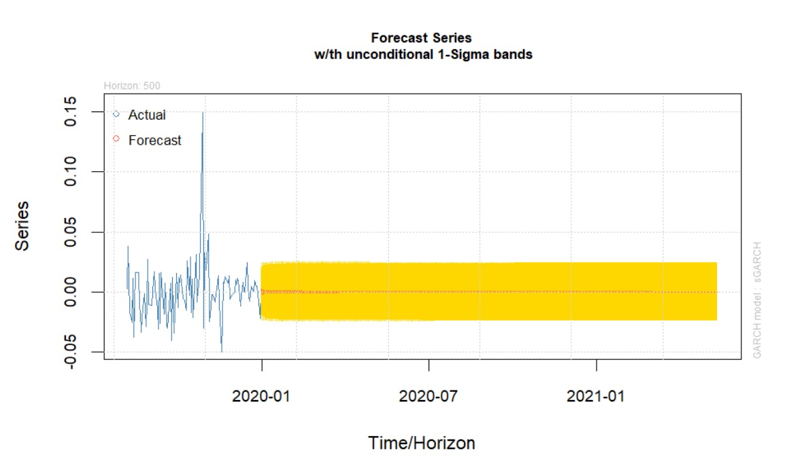

3

